EC2 + API + PostgreSQL + ML Model

1. Overview
This document provides a step-by-step procedure to deploy a machine learning application on AWS using: - EC2: Hosts API backend. - PostgreSQL Stores application and ML data. - ML Model: Hosted on EC2 for inference. - API Layer: Handles client requests and communicates with the database and ML model.

2. Step-by-Step Deployment.
Create a VPC
Go to VPC Dashboard → Create VPC.
Choose:
IPv4 CIDR: 10.0.0.0/16
Name: ml-vpc
Create Subnets:
Public Subnet (for EC2/API): 10.0.1.0/24
Private Subnet (for RDS): 10.0.2.0/24
Configure Route Tables:
Public Subnet → Internet Gateway
Private Subnet → No Internet Gateway (for security)
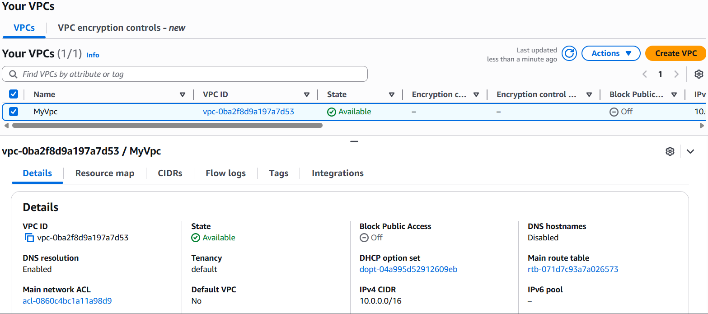
Launch EC2 Instance
Go to EC2 → Launch Instance.
Choose Amazon Linux 2023 or Ubuntu 22.04.
Instance type: t3.medium
Configure Network & Subnet:
VPC: My-Vpc
Subnet: Public Subnet
Configure Security Group:
Allow inbound HTTP (80) / HTTPS (443)
Allow SSH (22) from your IP
Allow outbound traffic to RDS on port 5432
Key Pair: create/download for SSH access
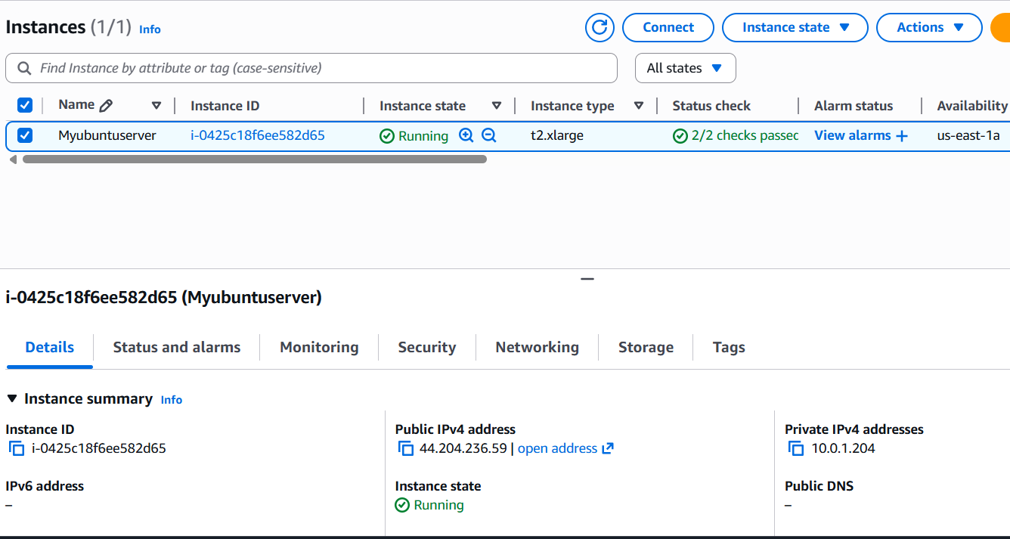
Update and install Python:
sudo apt update && sudo apt upgrade -y
sudo apt install python3-pip -y
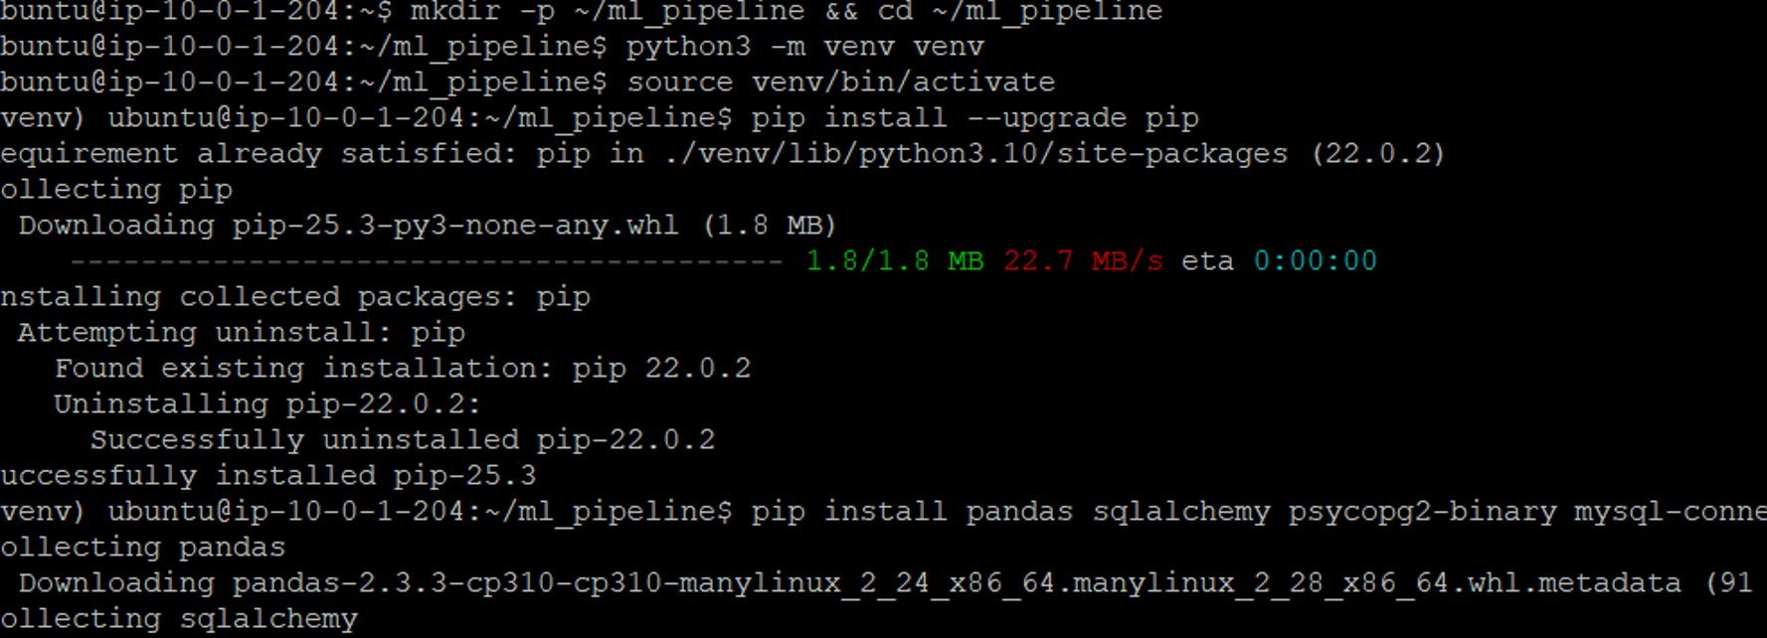
Connect to your portal data.
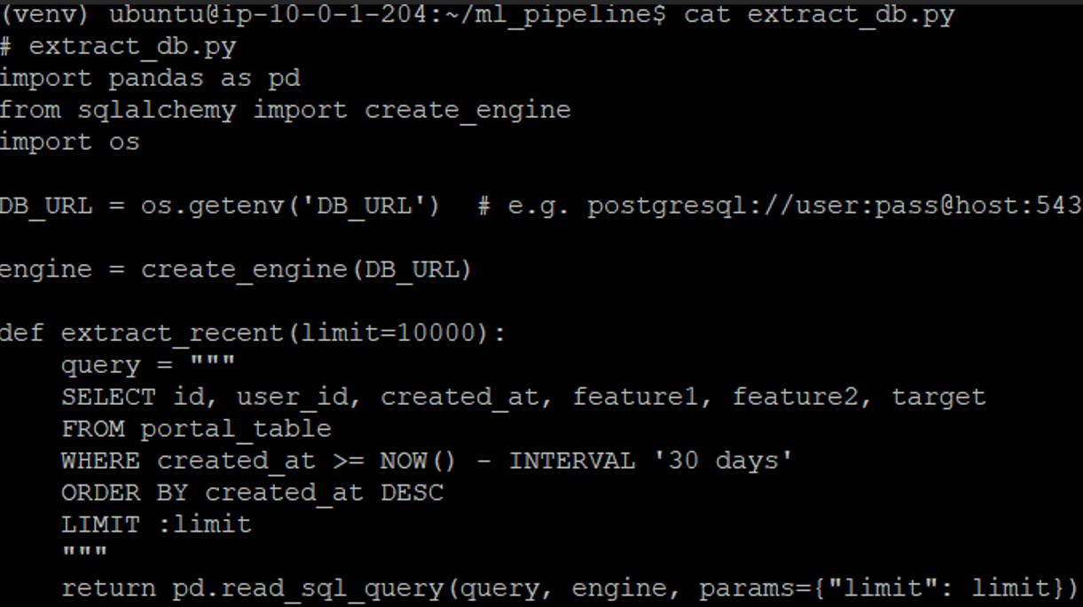
Set Environment Variable:
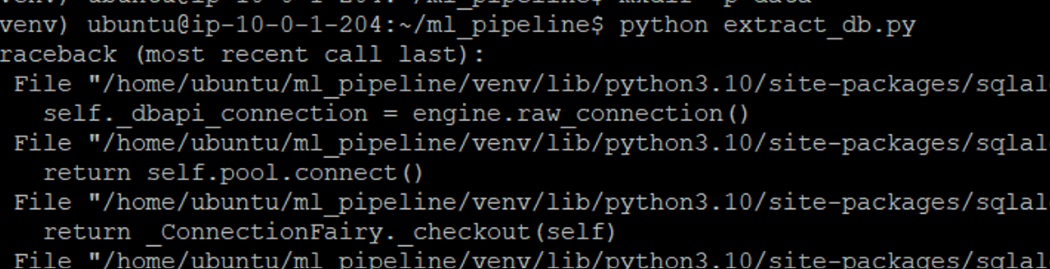
Create Database portal_db.
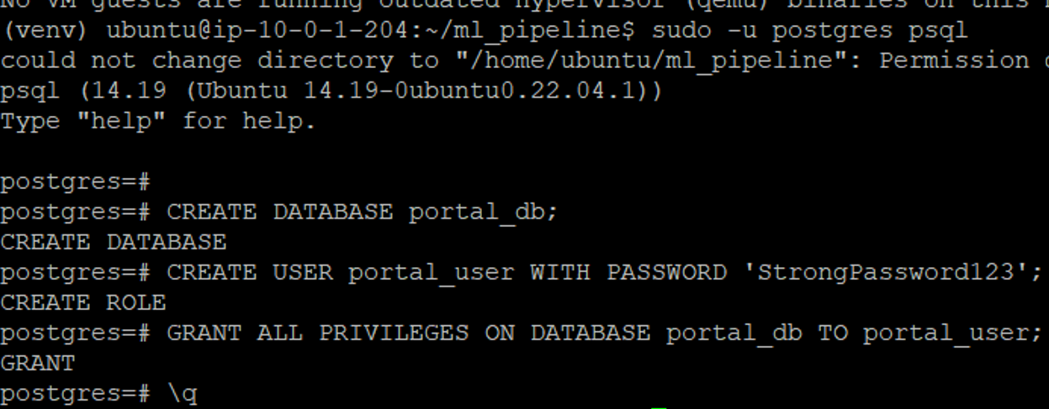
Create Tables and user inside portal_db.
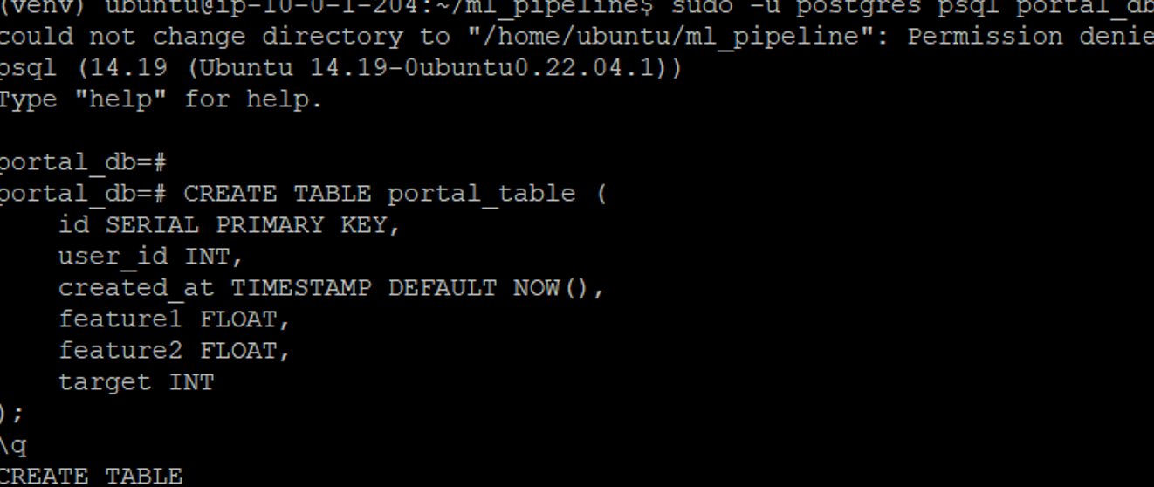
Grant Privlegdes to the user:
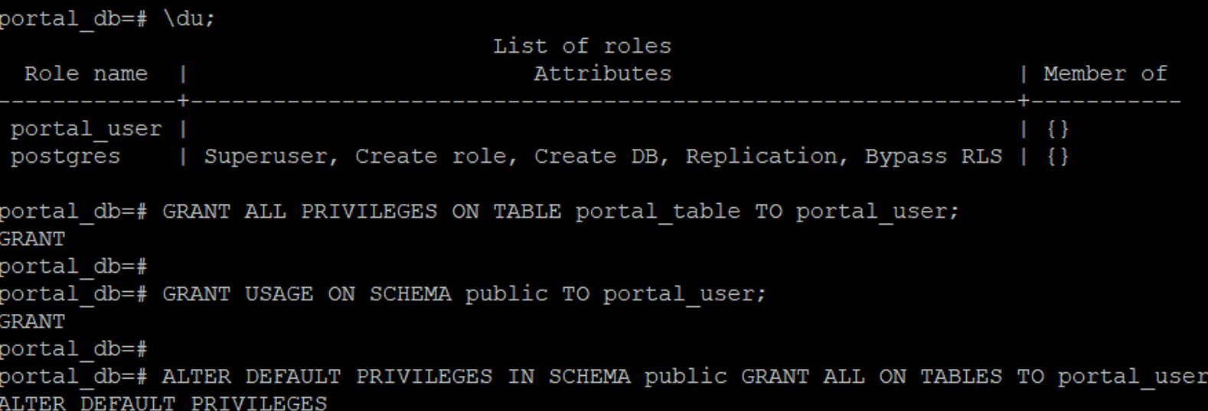
Create the files for Pipeline, Db_config and requirements.txt.
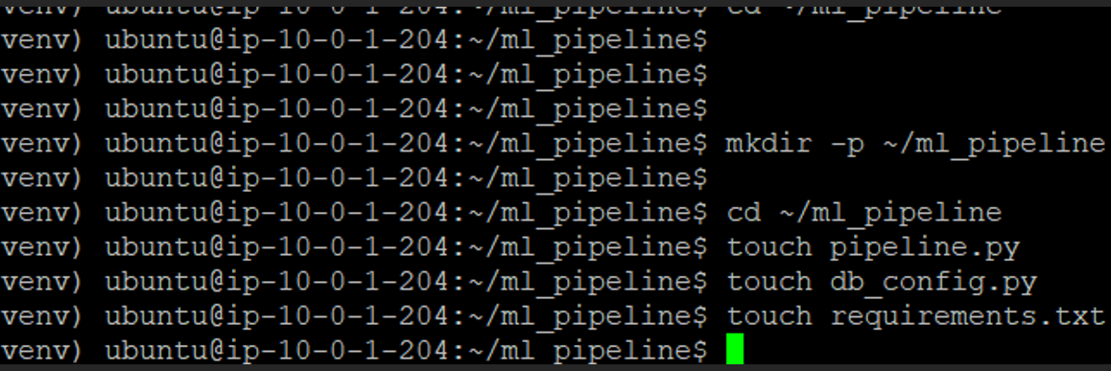
DB_Config.py.
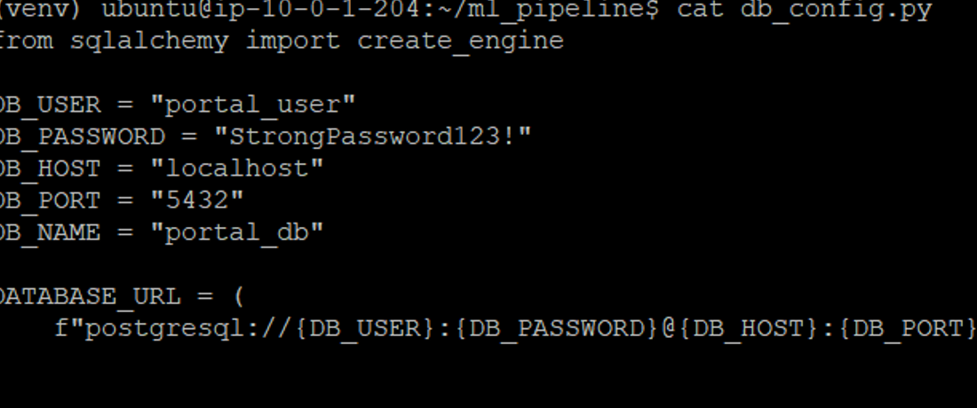
Pipeline.py
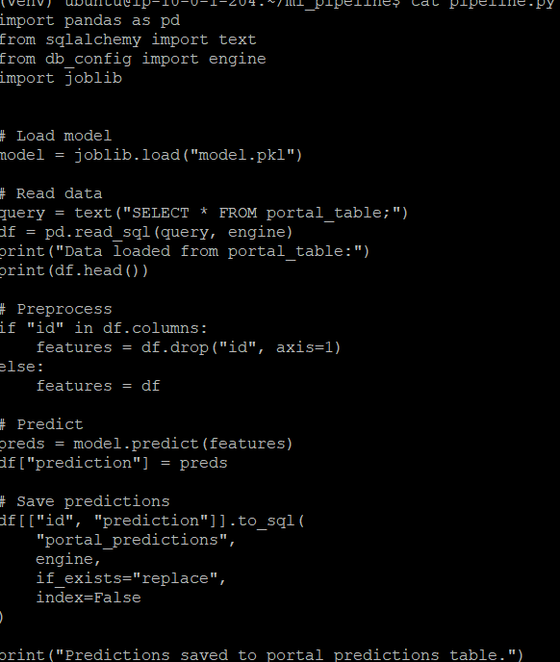
Requirement.txt
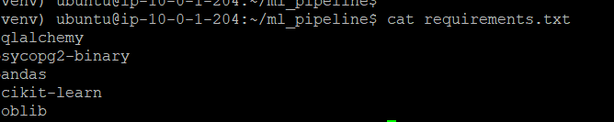
List the File structure inside m1_pipeline.
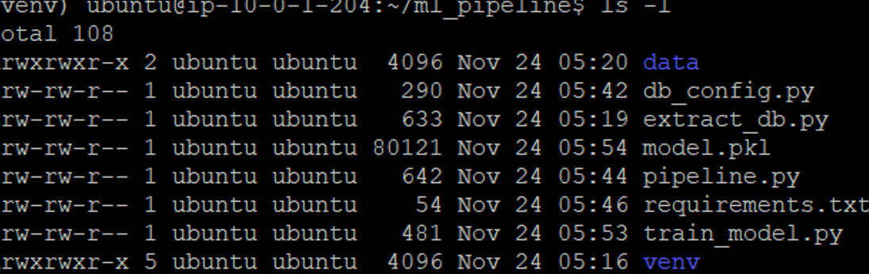
Run the Pipeline.
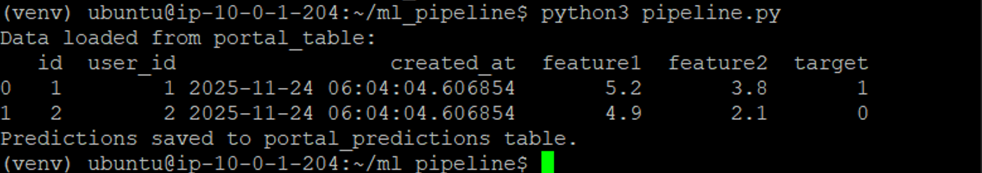
Build API to return prediction
Inside ~/ml_pipeline/api.py add the below file.
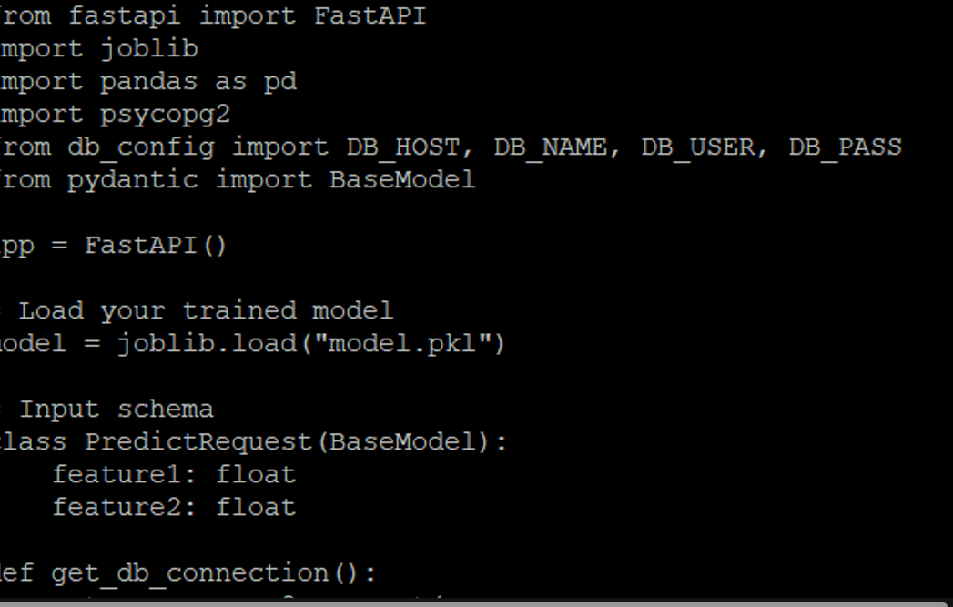
Run the API server
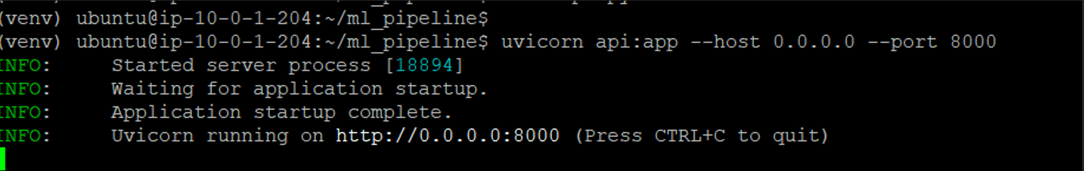
Check the database for the predictions Status.
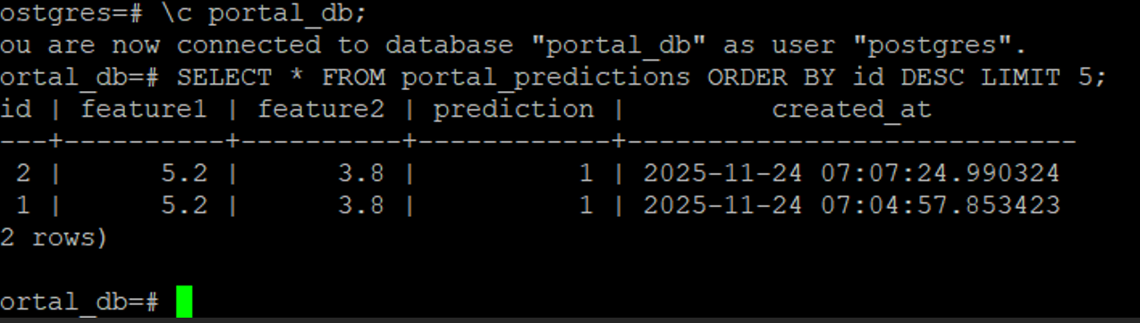
Test the API in the browser http://44.204.236.59:8000/predict/5.2/3.8.
